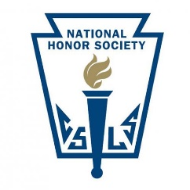

The National Honor Society chapter of Hamburg Area High School is a duly charted and affiliated chapter of this prestigious national organization. Membership is open to those students who meet the required standards in four areas of evaluation: scholarship, service, leadership, and character. Students are selected for membership by a majority vote of a five-member principal appointed faculty council, which bestows this honor upon qualified students on behalf of the faculty of our school each March.

Students in grade eleven are eligible for membership. For the scholarship criterion, a student must have a cumulative weighted grade point average of at least 99% after the first semester of his/her junior year. Each spring those students in grade eleven who meet this criterion are invited to complete a Candidate Form that provides the faculty council with information regarding the candidate’s leadership and service. Candidate Forms must be completed and turned in by the required date and time to be considered.

To evaluate a candidate’s character, the faculty council used two forms of input. First, school disciplinary records are reviewed. Second, members of the faculty are solicited for input regarding their professional reflections on a candidate’s service activities, character, and leadership.

Any solicited faculty input and all Candidate Forms are carefully reviewed by the faculty council to determine membership. A majority vote of the council is necessary for selection. Candidates are notified regarding selection or nonselection according to a predetermined schedule.

Following notification, a formal induction ceremony is held at the high school to recognize all the newly selected members. Once inducted, new members are required to maintain the same level of performance (or better) in all four criteria that led to their selection. As a member of National Honor Society, students will be expected to attend monthly meeting, participate in at least three NHS sponsored service projects as well as other NHS sponsored fundraisers and activities.